Annex 1

ORGANISATIONAL STRUCTURE OF THE LEGAL ENTITY UNDER PUBLIC LAW CALLED THE PENSION FUND

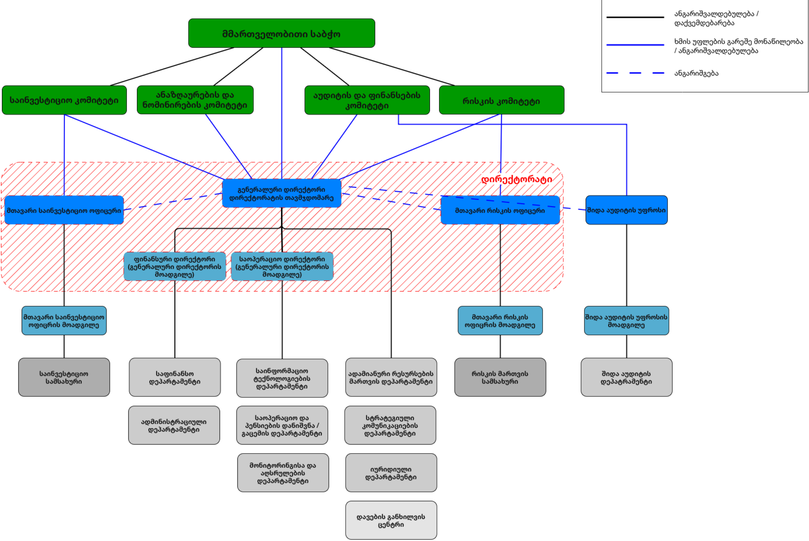
THE GOVERNING BOARD
Chief Investment Officer
Investment Service
Accountability/ subordination
Financial Director (Deputy Director General)
Risk Committee
Audit and Finances Committee
Remuneration and Nomination Committee
Investment Committee
Head of Internal Audit
Chief Risk Officer
Director General Chairperson of Directorate
Operational Director (Deputy Director General)
Deputy Head of Internal Audit
Deputy Chief Risk Officer
Deputy Chief Investment Officer
Administrative Department
Department of Operations and Fixing/Payment of Pensions
Legal Department
Internal Audit Department
Risk Management Service
Department of Human Resources Management
Information Technology Department
Finance Department
Strategic Communications Department
Monitoring and Execution Department
Directorate
Dispute Resolution Centre
Reporting
Participation without right to vote/Accountability

